1 INTRODUCTION

TRACING THE GROWTH OF THE GLOBAL COMMUNITY

The world’s population is more than three times larger than it was in the mid-twentieth century. The global human population reached 8.0 billion in mid-November 2022 from an estimated 2.5 billion people in 1950, adding 1 billion people since 2010 and 2 billion since 1998. The world’s population is expected to increase by nearly 2 billion persons in the next 30 years, from the current 8 billion to 9.7 billion in 2050 and could peak at nearly 10.4 billion in the mid-2080s.

This dramatic growth has been driven largely by increasing numbers of people surviving to reproductive age, the gradual increase in human lifespan, increasing urbanization, and accelerating migration. Major changes in fertility rate have accompanied this growth. These trends will have far-reaching implications for generations to come.

Global community refers to the growing interconnectedness of people around the world. It's made up of people from all over the world who're connected by gender, interests such as technology, economics, global issues, and more.

A global society or a global community is defined by characteristics such as worldwide awareness, communication, economy, and politics. In short, what global means is anything having to do with the world as a whole.

PURPOSE

The people or nations of the world, considered as being closely connected by modern telecommunications and as being economically, socially, and politically interdependent.

Global Communities delivers essential solutions to complex challenges from the intersection of humanitarian assistance, sustainable development and financial inclusion.

2 PROBLEM DEFINITION &DESIGN THINKING

EMPATHY MAP

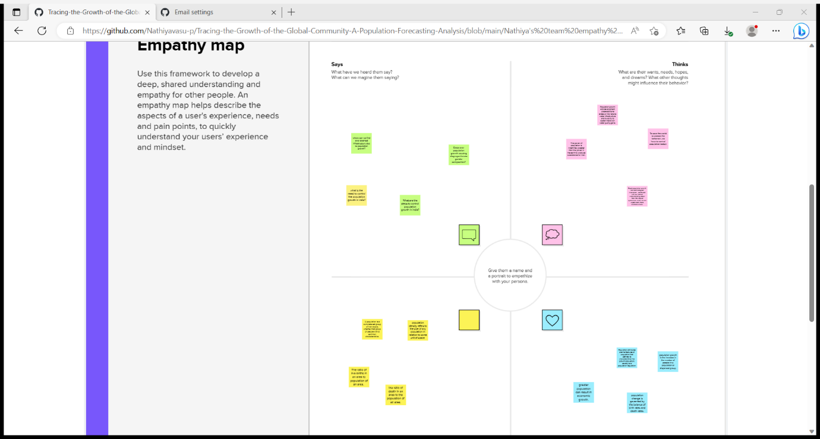

BRAINSTROM AND IDEA PRIORITIZATION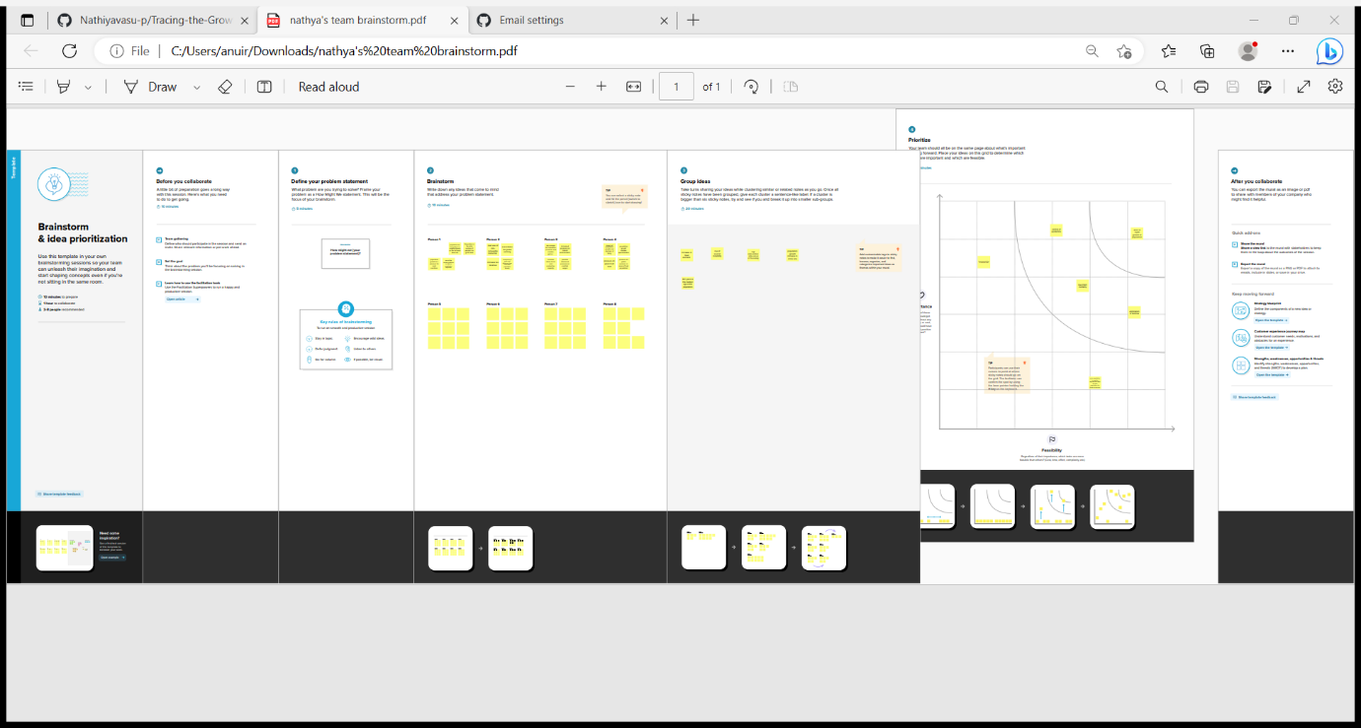

3 RESULT

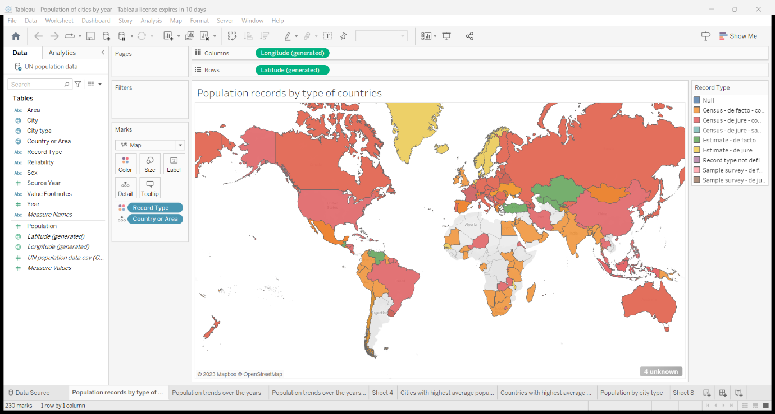

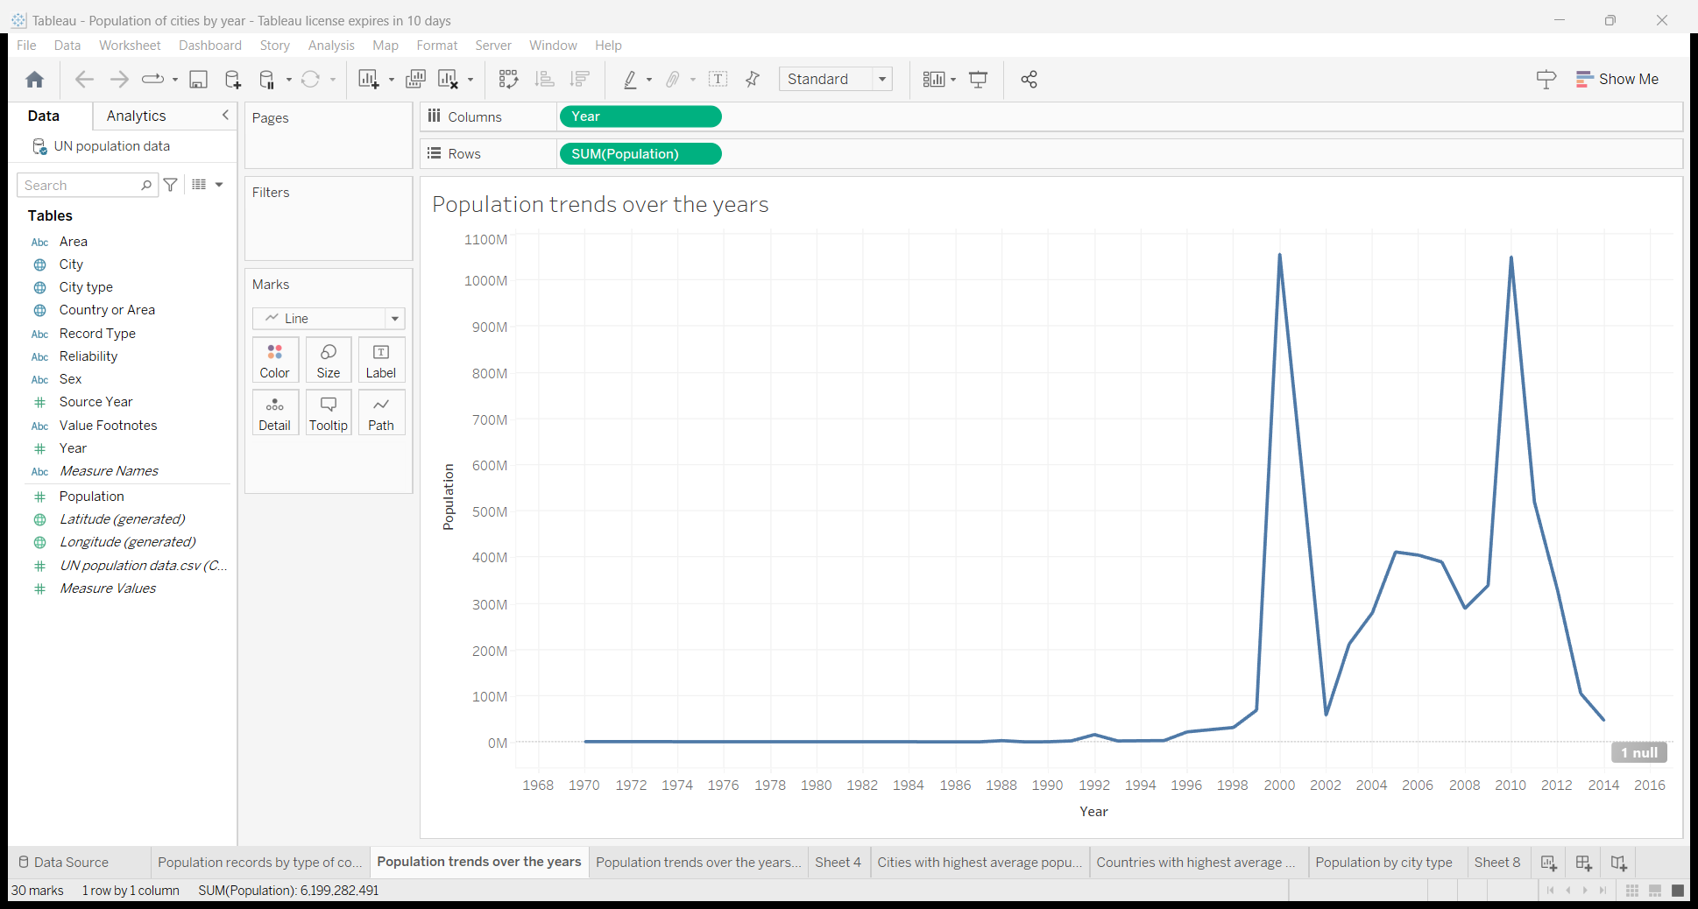

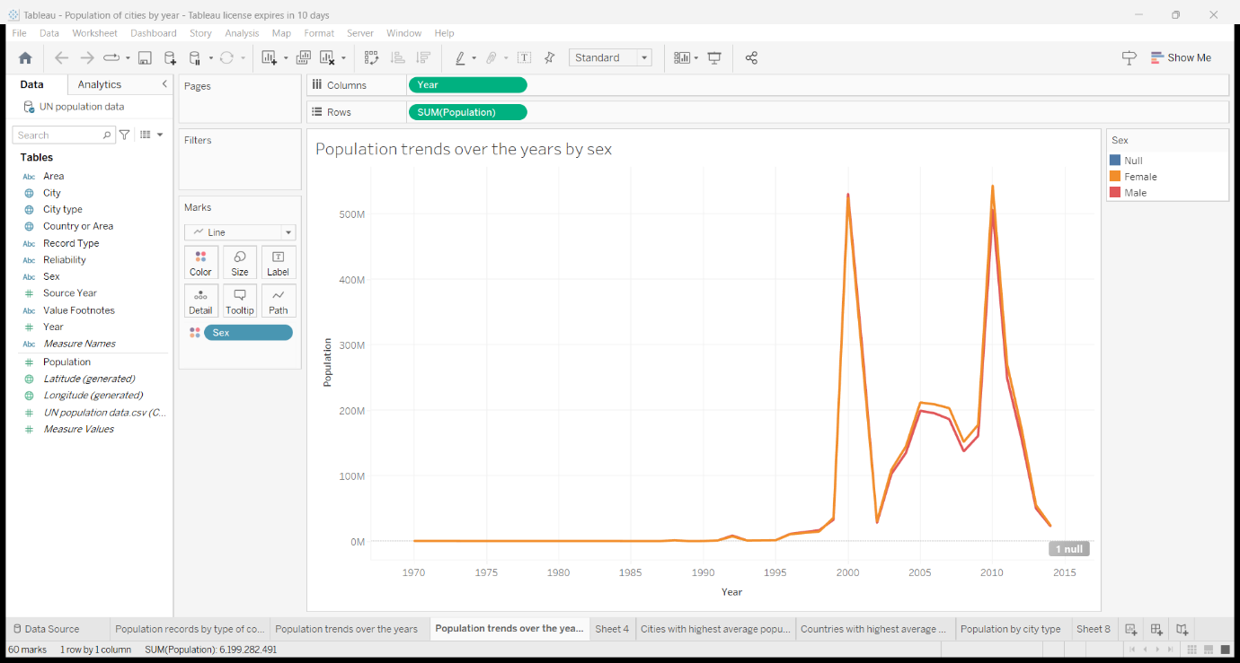

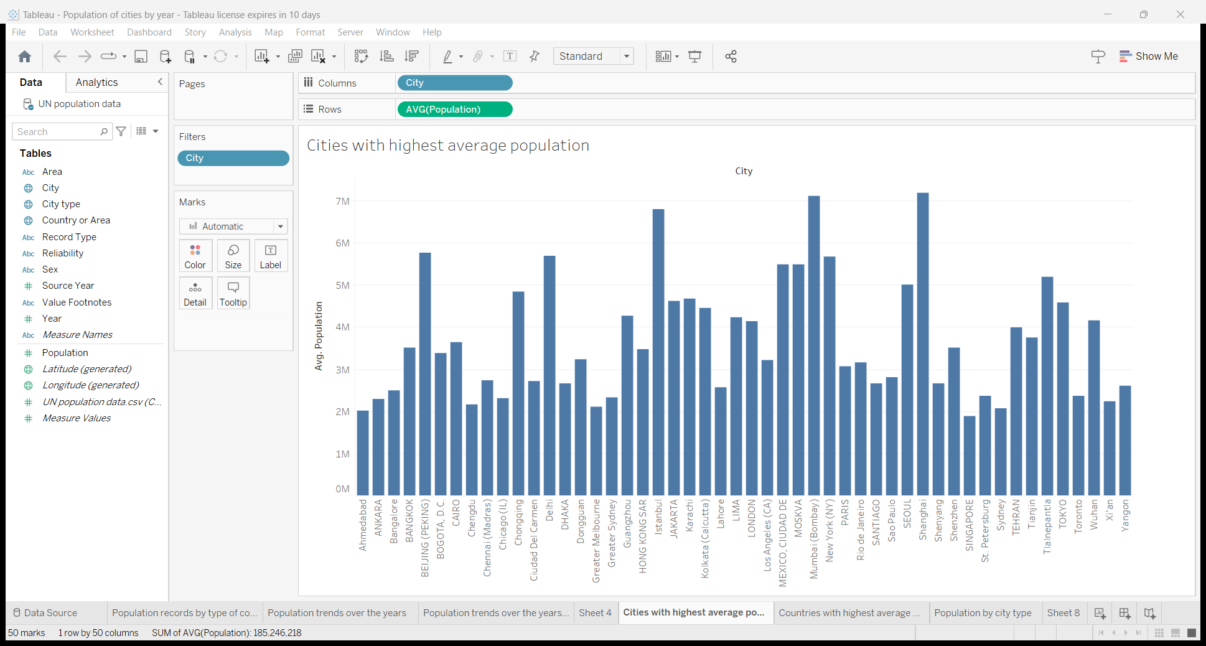

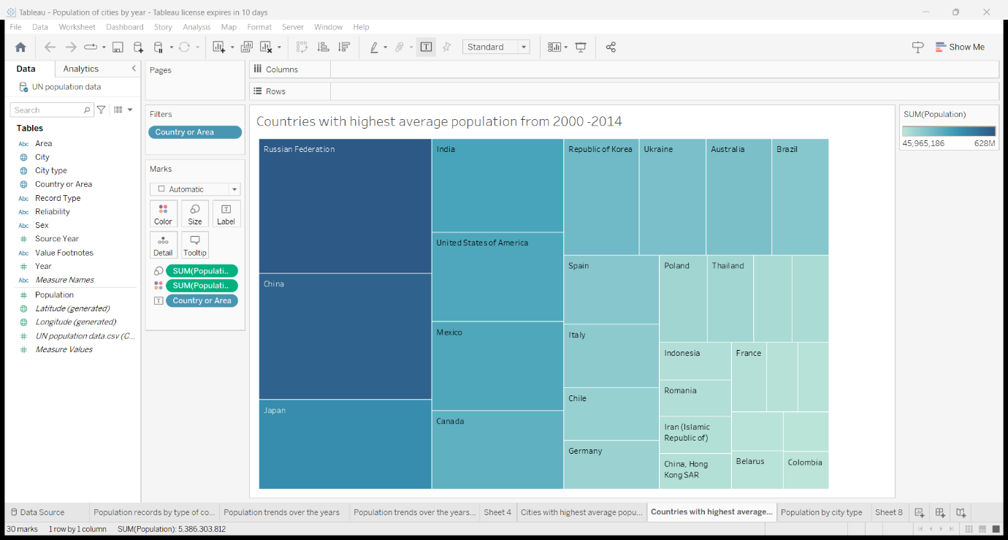

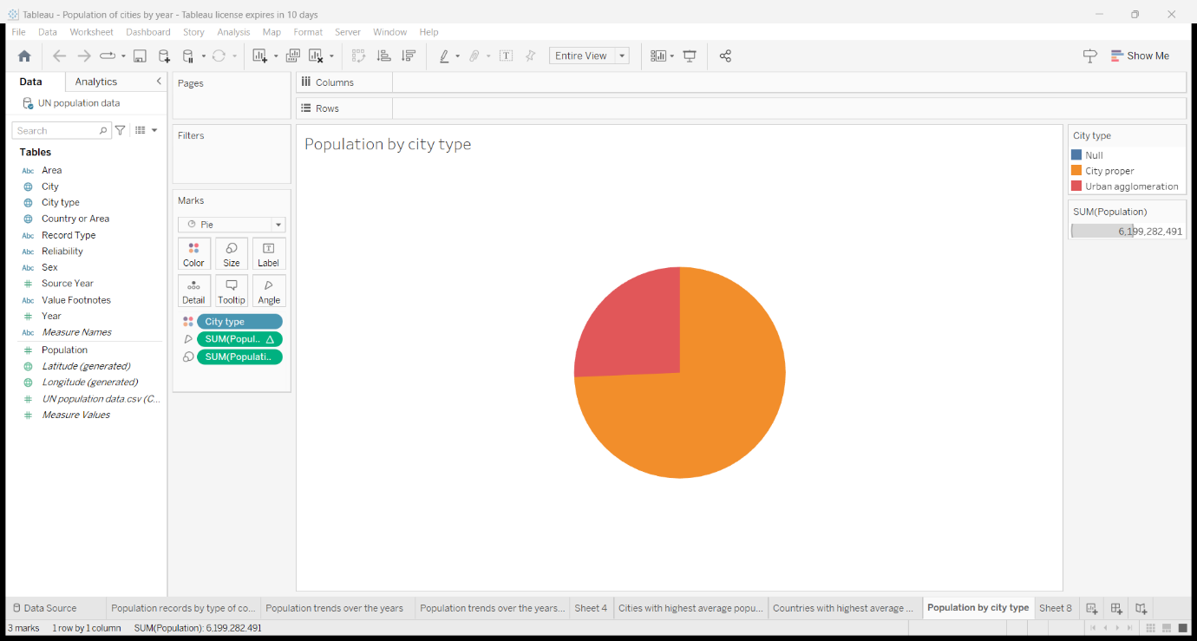

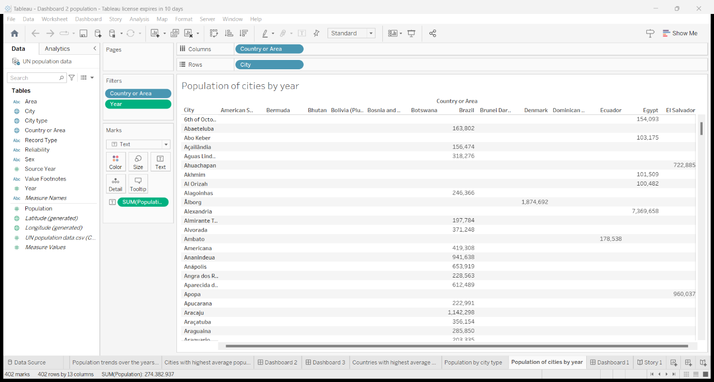

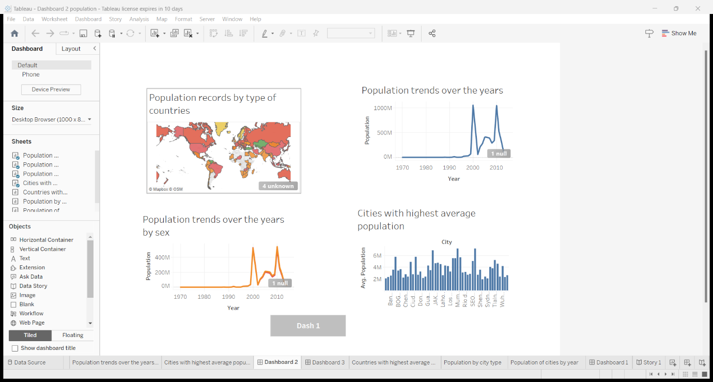

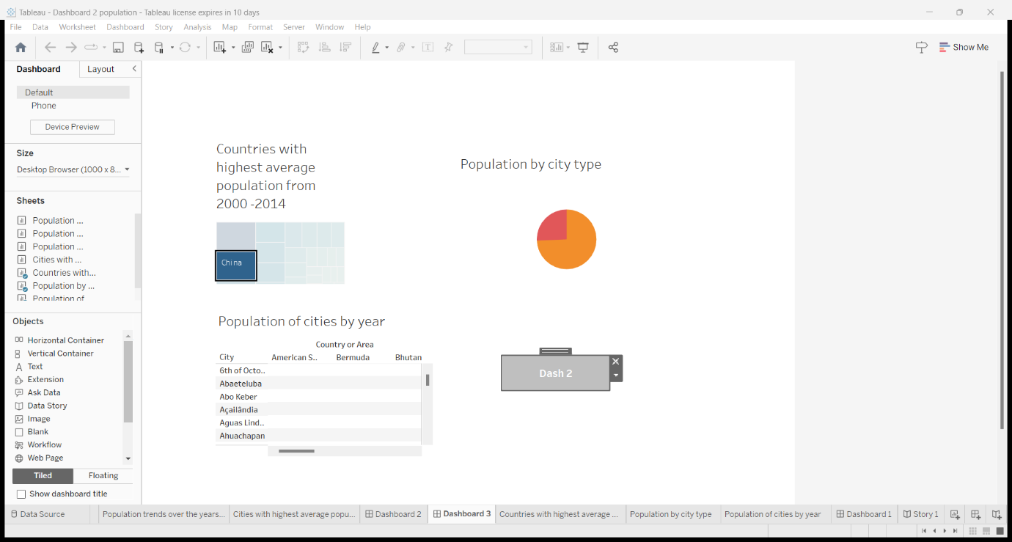

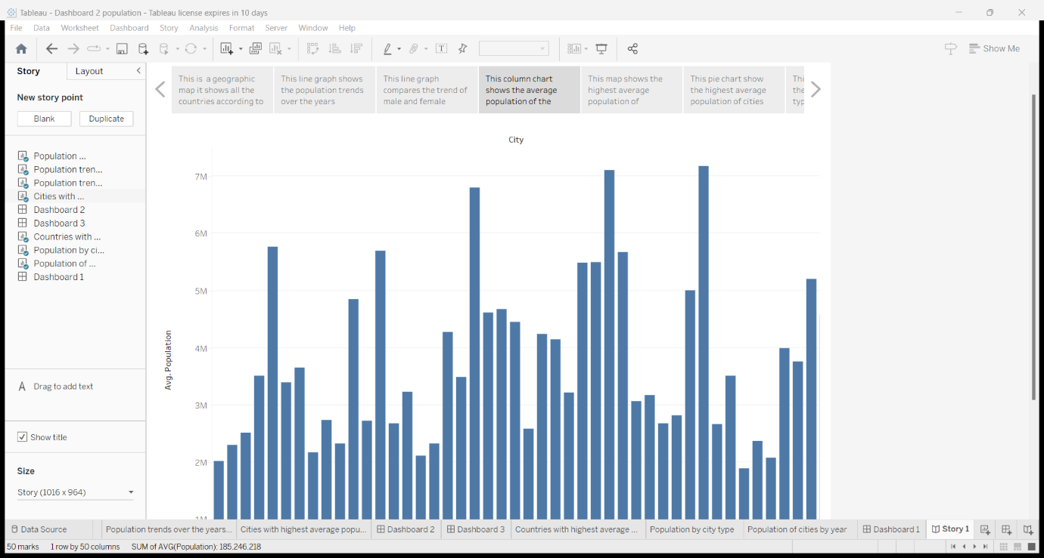

4 ADVANTAGES

**Greater economic growth**

Population growth will lead to economic expansion since more people can produce more goods. More money will be available in tax revenue to fund public services like environmental and health care programs. The obvious conclusion is that GDP per capita is the essential element rather than GDP as a whole.

**Human Resources will Increase.**

One obvious advantage that a large population might offer is a larger supply of human resources. In locations where unemployment is a serious problem, this will likely not lead to more jobs, but it will boost the number of individuals willing to work for less pay.

**Increased productivity through specialization**

The demand for products and services will rise as the population grows, encouraging specialization. This indicates that some people concentrate on creating a single product or service. However, each person's efforts may merge into something amazing depending on their distinct abilities and talents.

Additionally, specialization enables countries to export and participate in globalization. Producers can export commodities to areas afflicted by natural catastrophes or artificial risks instead of only producing locally.

**Demand has led to more jobs.**

More people means a greater demand for products and services, so more jobs are needed for production. Workers are needed at every level, from the production of basic materials through multiple stages to final distribution during consumption.

More employees are necessary throughout this procedure; thus, they can be needed today even if they weren't previously required for certain talents. Several countries are investing in regulating declining birth rates to address the impending labor deficit.

DISADVANTAGES

**Increasing Resources Demand**

Demand for resources rises as the population grows. Resources, however, are in infinite quantity; thus, this is an issue because if a large number of people utilize them, they'll run out and become scarce, resulting in poverty.

Natural resources will be depleted more quickly due to increased non-renewable resource usage brought on by an increase in population.

**Shortage of food due to population expansion**

More people means more people to feed, which strains food availability. As a result, food shortages are common in developing countries with quickly growing populations. They cannot feed their expanding population despite their efforts to raise agricultural output.

There are two effects on the growth of the economy from food scarcity. First, a lack of food results in undernutrition, which lowers productivity. It further reduces the workers' capacity to produce. Second, food scarcity requires countries to buy grains, which unnecessarily depletes their foreign exchange reserves.

**Generating Non-biodegradable waste**.

We are now battling to process the non-biodegradable waste that we are producing. It usually ends up in a landfill, contributing to harmful issues like methane emissions.

**Increase Pollution**

More people will produce more air, water, and land pollution. Numerous health problems, including asthma and cancer, are linked to higher pollution levels. The pollutants also harm animals and vegetation.

**Threat to Natural Habitat**

As there is a growing need for houses and farming due to an increasing population, there will be a greater threat to natural ecosystems. As a result, there will be more pressure to clear forests to make room for agriculture and habitation.

5 APPLICATIONS

The spatial aggregation of addresses open data to produce population distribution maps with a fine spatial resolution resulted in reliable grids, created in a simple and fast way, which is a major contribution towards cost-saving, time-saving, and scientific sound. The proposed methodology makes it possible to produce up-to-date and reliable population estimates, between censuses, if there are new data on addresses and the auxiliary variable relative to the weight of the population/population density is coherent in time and space. In contexts of urban expansion and/or urban regeneration with significant changes in urban planning parameters, the methodology can be applied if the weights of population density can be obtained from other proxy variables, namely the indexes of master plans.

6 CONCLUSION

Providing per capita incomes are rising, then population growth increases the size of domestic markets - encouraging economies of scale in production and increased capital investment spending by businesses.

7 FUTURE SCOPE

Global Overview. Global real GDP is forecasted to grow by 2.2 percent in 2023, down from 3.3 percent in 2022. Most of the weakness will be concentrated in Europe, Latin America, and the US.

Liu highlighted three mega-trends related to globalization: “Shifts in production and labor markets; rapid advances in technology; and climate change.” These trends are expected to shape and influence our future.

8 APPENDIX

<https://drive.google.com/file/d/1UGM7jdNwII4fu7X-h88yAq7u9fEpBY4O/view?usp=drivesdk>